#### SRI KRISHNA COLLEGE OF TECHNOLOGY

**An Autonomous Institution | Accredited by NAAC with 'A' Grade Affiliated to Anna University | Approved by AICTE**

#### KOVAIPUDUR, COIMBATORE 641042

**GIFT CRAFT MARKETPLACE**

#### A PROJECT REPORT

***Submitted by***

**ABHISHEK.P 727821TUIT005**

**AKSHAYA.D 727821TUIT008**

**HEMAHARSHINI.K.J 727821TUIT035**

***in partial fulfillment for the award of the degree of***

#### BACHELOR OF TECHNOLOGY

#### IN

**DEPARTMENT OF INFORMATION TECHNOLOGY**

#### April 2024

**GiftCraft MarketPlace : A Gift Customization Portal**

**Introduction:**

A digital platform designed to give best gifting experience. It’s a space where users can browse through a vast array of customizable gifts, ranging from jewelry to home decor, all in one convenient location. With intuitive features, users can easily navigate through the portal, selecting and personalizing their chosen items with ease. Our portal aims to simplify the process of finding and creating the perfect gift.

With an intuitive dashboard, administrators can effortlessly add, edit, or remove products, ensuring a dynamic and up-to-date catalog.

**Objective:**

An online customized gift portal is a platform that allows users to create and purchase personalized gifts for various occasions. These portals offer a wide range of customizable products, allowing customers to add their personal touch to gifts.

Build an application that customers can buy customized gifts online. The customers can choose themes, gifts, select gifts, order online. The user will have option to edit and cancel the order.  The order value should be generated automatically. The admin can add new themes, delete the themes, edit the theme details and view themes The admin can also add, edit, view and delete gifts to be customized. Customer can provide reviews.  Customer can make the payments.

**User Flow Chart:**

Login Page

Billing Page

Cart Page

Register Page

**isRegister?**

**isLoggedIn?**

Clicking on **“Add To Cart”**

Home Page

Products Page

**User Modules:**

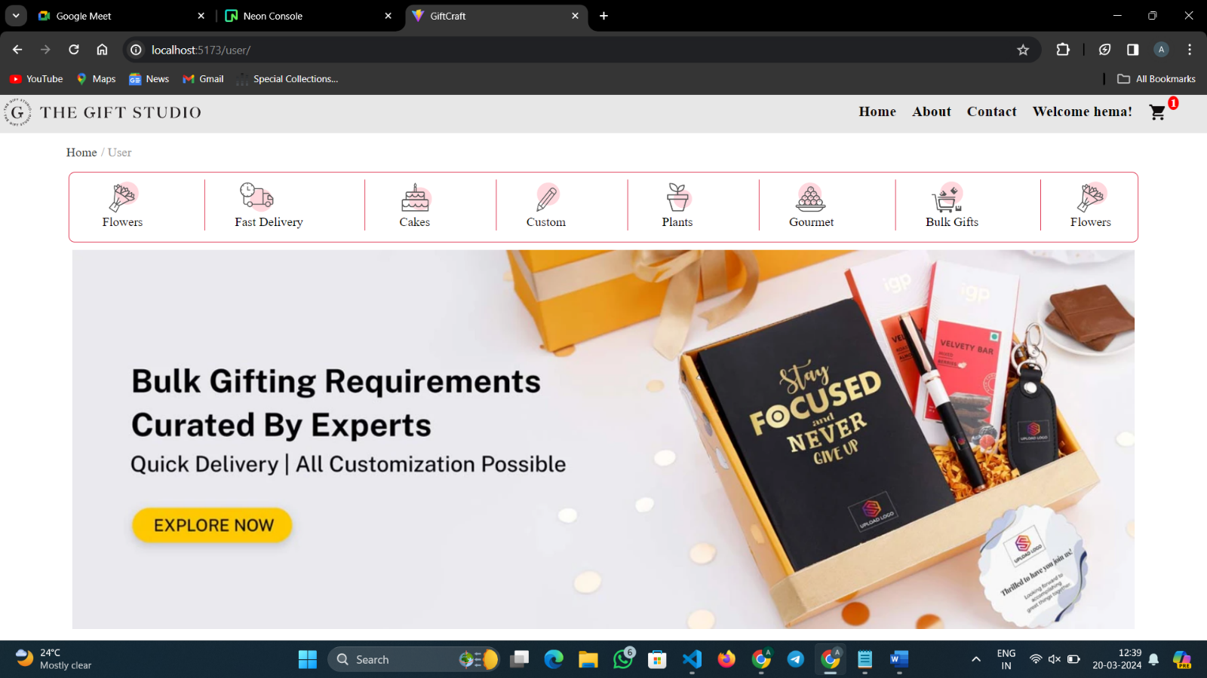

**Home Page**

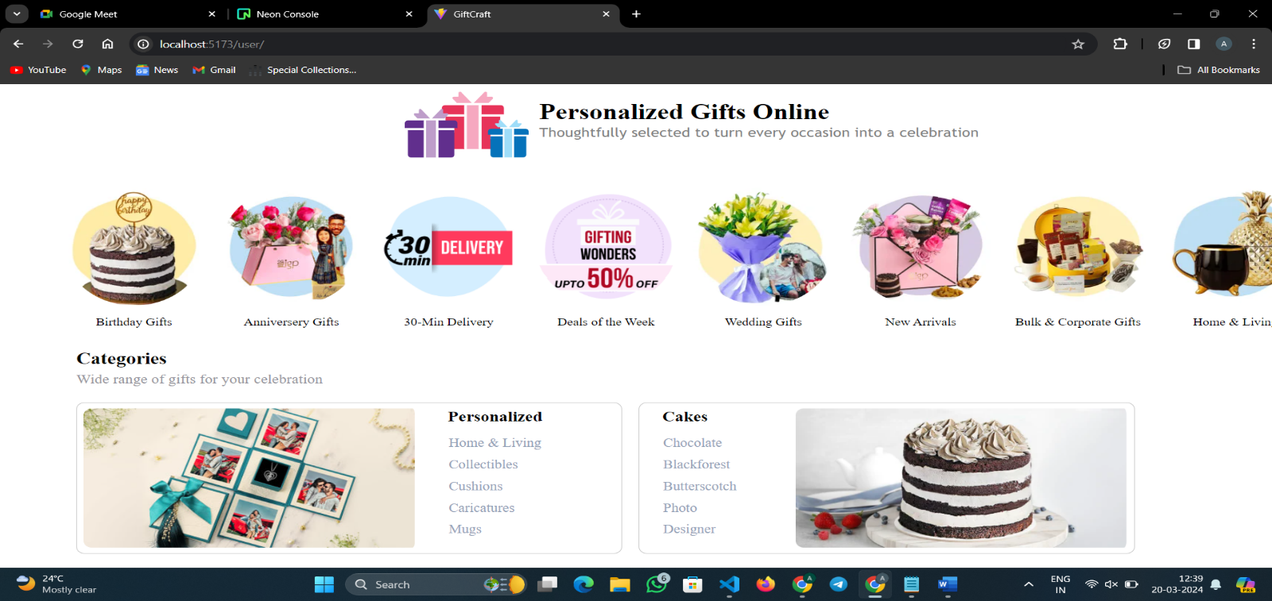

**Products Page**

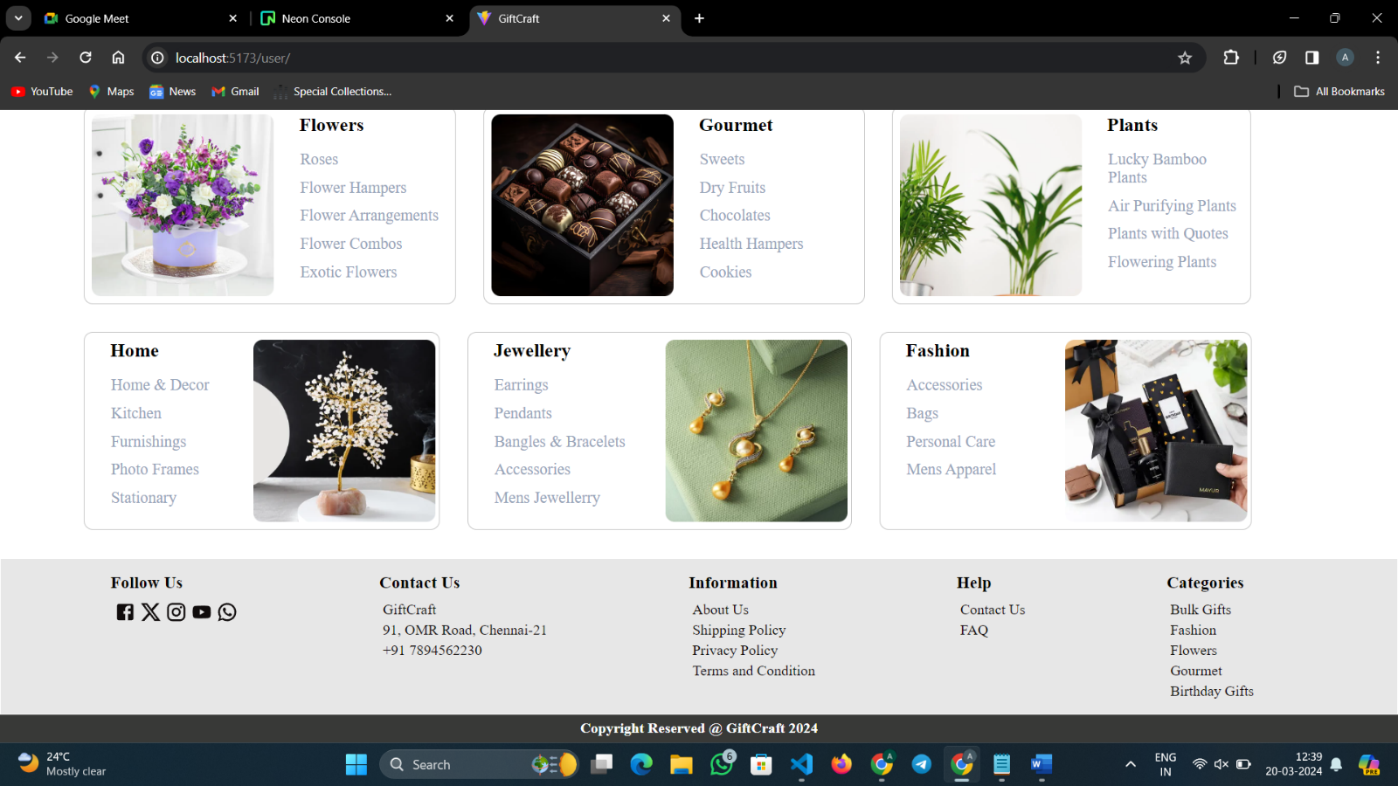

**Footer**

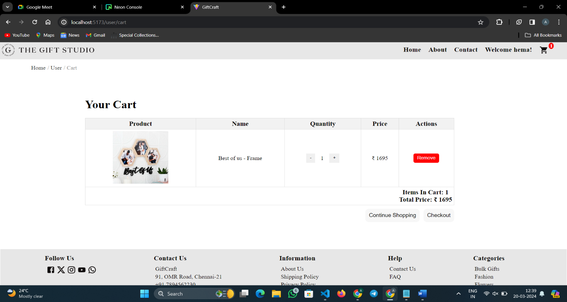

**Cart Page**

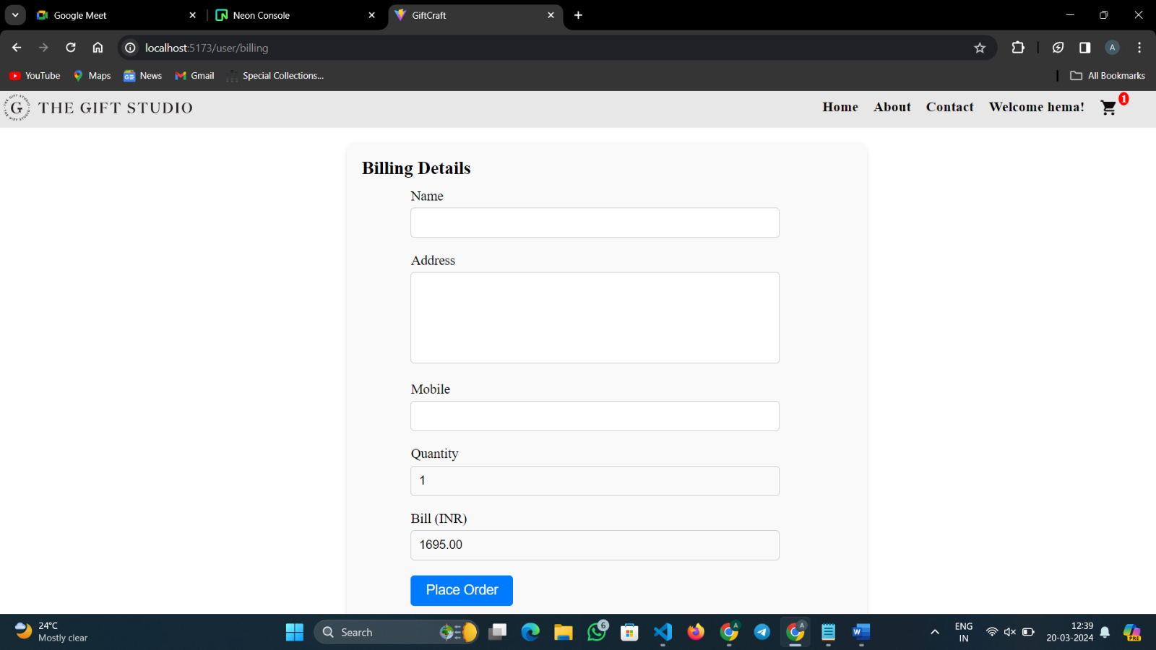

**Billing Page**

**Admin Flow Chart:**

Home Page

Login Page

**isLoggedIn?Admin**

Dashboard

Add Product

User Information

Order List

Add Category

**Admin Modules:**

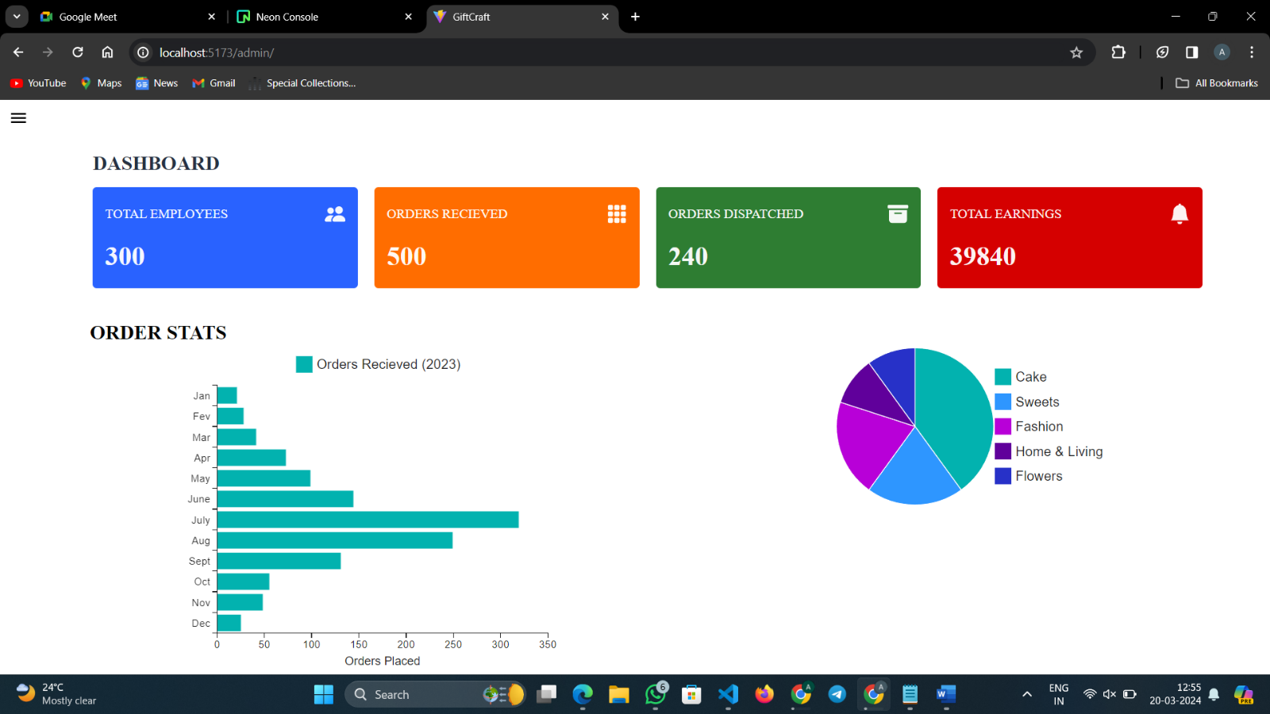

**Dashboard**

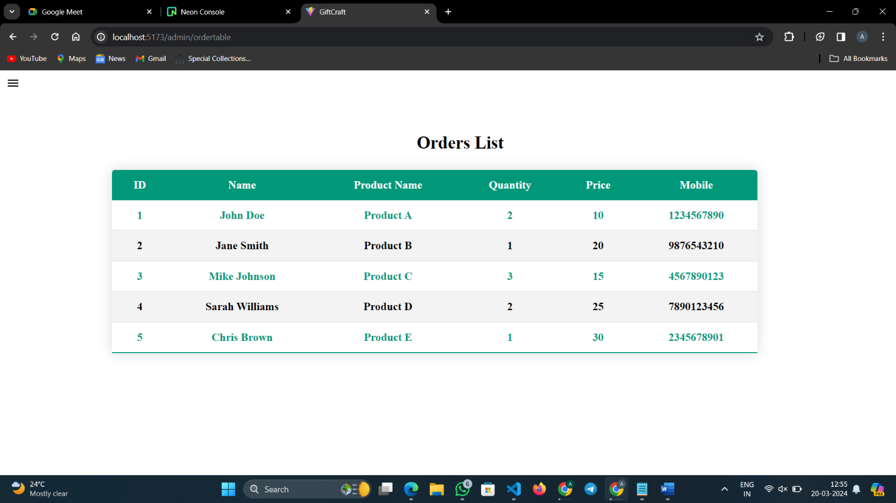

**Order List**

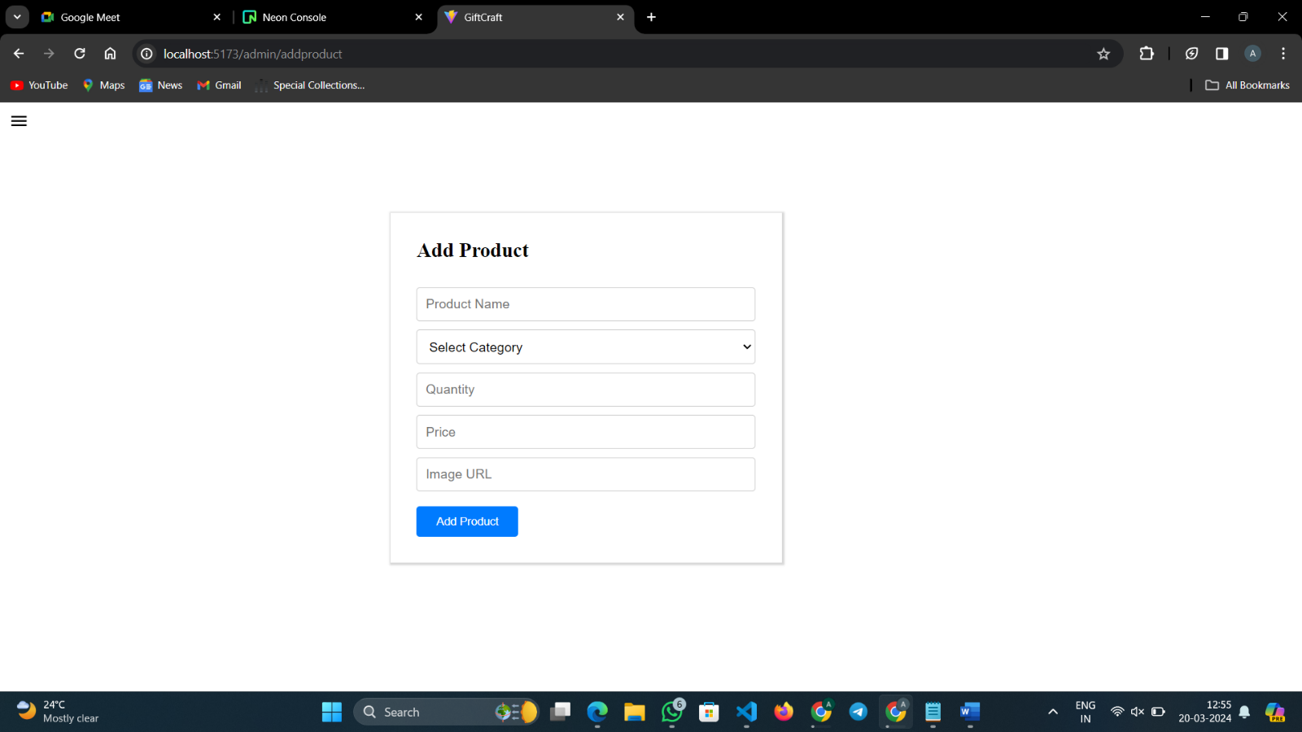

**Add Product Page**

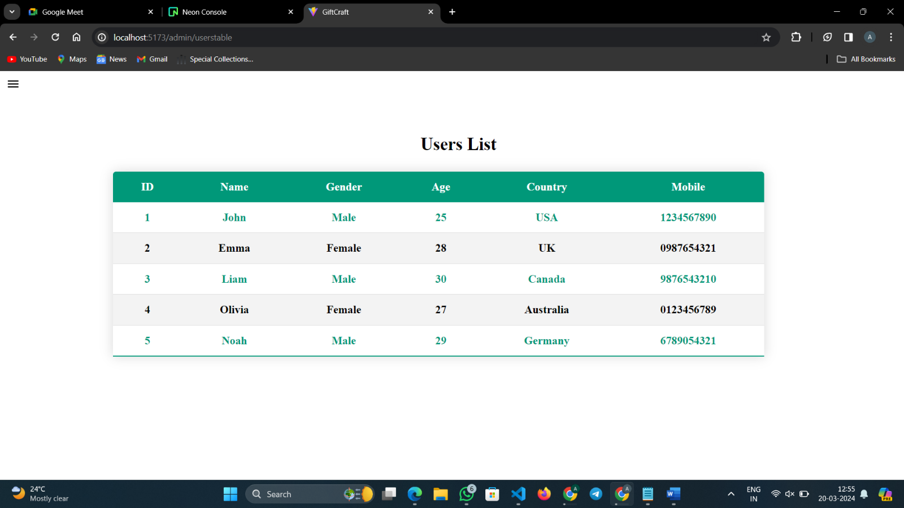

**User List Page**

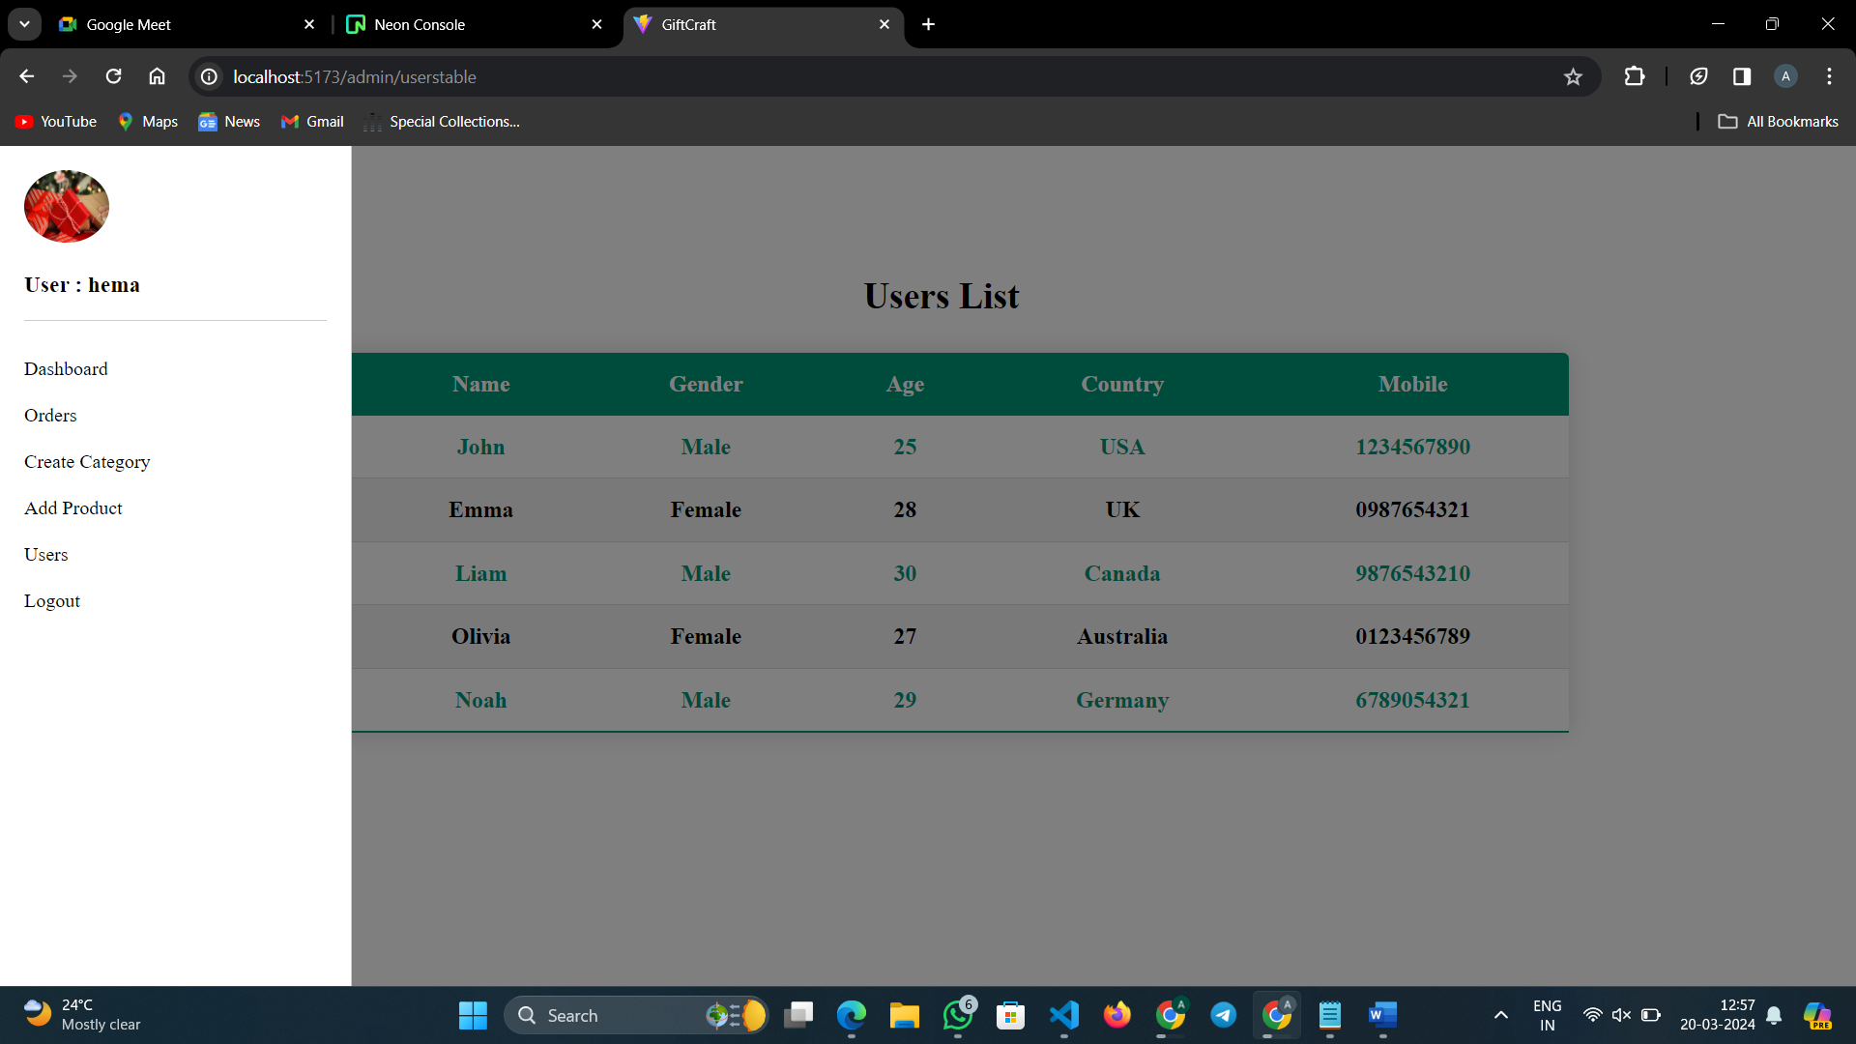

**Admin Side Bar**

**Conclusion:**

The gift customization app allows users to create personalized gifts by customizing various items like mugs, keychains, and more. Users can register, browse products, customize them with messages and images, and place orders securely. The app also includes features like order tracking, social media sharing, and essential links for user support. Overall, it offers a convenient platform for creating unique and thoughtful gifts for any occasion.